NEWSletter
Relationship, Development, and
Evangelization
Paris, France
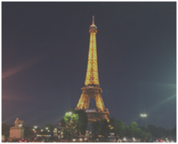
YEPP RELATIONSHIP - Reporting from Paris, France
We left from the city of Dacula at 3:40pm to head to the Hartsfield- Jackson Atlanta International Airport. Our flight took off at 8:15pm, and we arrived in Paris at 10:40am. The following morning upon arrival, we were picked up by our guide to head to Rocquencourt, France. And were immediately amazed by the cleanliness of the environment and how the beautiful lush and well maintained gardens were everywhere. They were so peaceful and almost tranquil and were everywhere.
When we reached to our destination, we took the day to rest (Monday June 18th). I took the liberty to cook dinner for everyone. There were eight people at the dinner people- four from Georgia and four newly found friends from France.
On Tuesday morning, we had a time of devotion from 2 Timothy 4, the discussion on the chapter, which gave us the opportunity to engage and fellowship together. Afterwards, we confirmed our first church meeting which was held later that morning at 10:00am in Boulogne with one of the pastors (on the pastoral team of add name of church). At the meeting, we had the chance to meet Pastor Andre and his wife, where they shared great news with us for the next mission trip the following year. Pastor Andre also invited us to a music evangelization event for later in the week, so that we could be involved in the work that the church had planned to do street evangelism in Boulogne, France which the church had to get a permit from the Police Department.
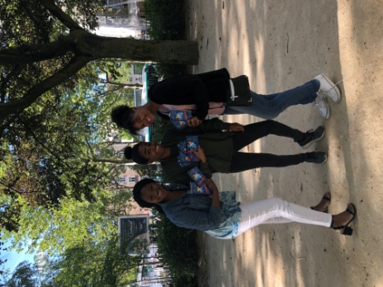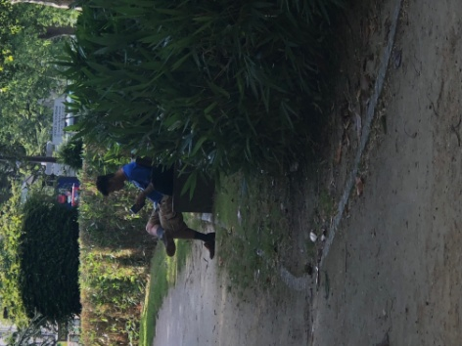
The following day, we had our next meeting with a Petit Troupeau where we discussed Luke 12:32, “Do not be afraid, little flock, for your Father has been pleased to give you the kingdom.” The church was located in the city Goussah France and the meeting went so well that they invited me to preach the upcoming Sunday, June 24th at 11am. The relationship with the churches was completed!
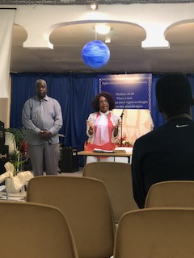
On Thursday morning, we visited the Chateau De Vincennes. Many of the buildings were closed except one since there was an employee strike going on. In the building that we did enter, we learned a lot of history and information about the runaway slave from USA that became a great pilot that helped France during the war.
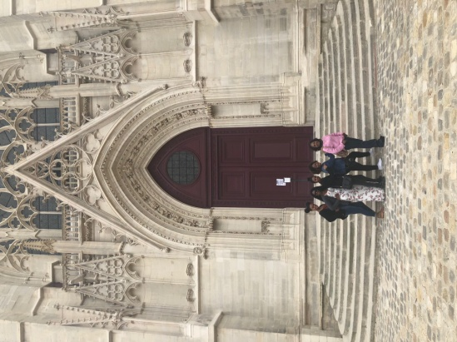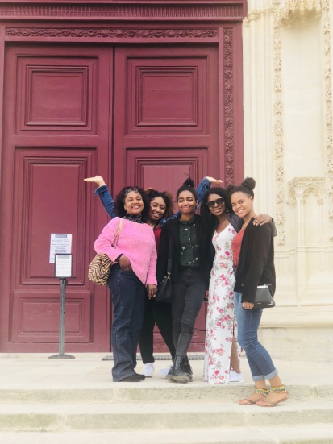
On Friday morning, we visited the Palace of Versailles, where I lost my phone. At the end of the day, the rest of the team chose to go to Paris to walk around to see Paris lit up and eat ice cream. I remained in prayer with Pastor Leone, who is also a part of the pastoral team, in Boulogne at the church of Point Du Jour, where we previously had met Pastor Andre, and did our street evangelization.
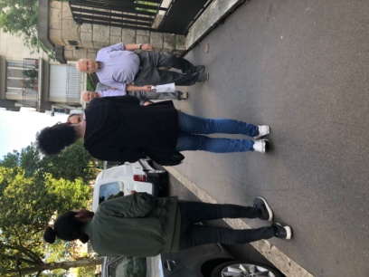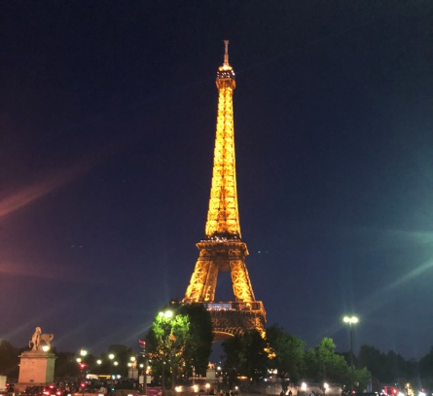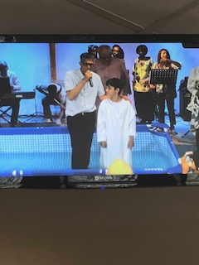
We also had the chance to witness a live baptism at Point Du Jour Church on Sunday.
Our mission experience was very challenging, since one of my team members misplaced their passport and couldn't go. Although I experienced many challenges, I kept on moving with a positive attitude. We had the chance to be able to work in Jesus’ name with evangelism and creating relationships.

We invite you to come to Mission with us next year on July 21st to July 29th
Register online at: www.TOLMIN.org or text/call 404-933-9172
P.O. Box 727 Dacula, GA. 30019

